Without any Statistical Method Lidar Will compute Wrong TTC Because there is noise affect in result :

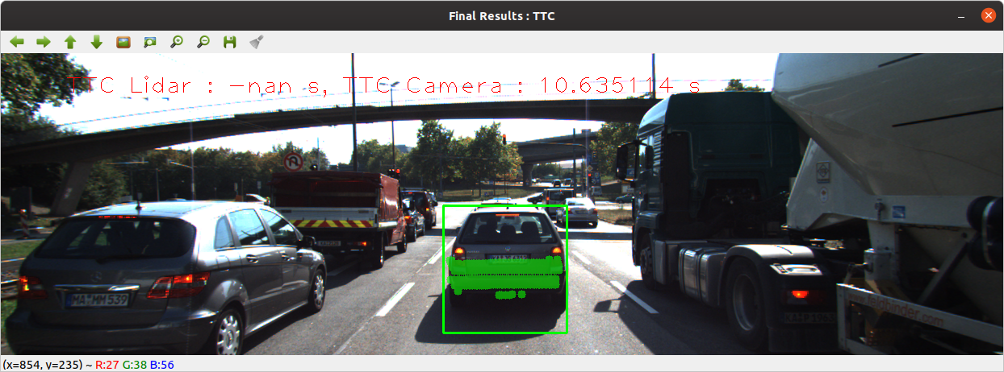
Here With Median Method By Collect All Point and take which at middle :

